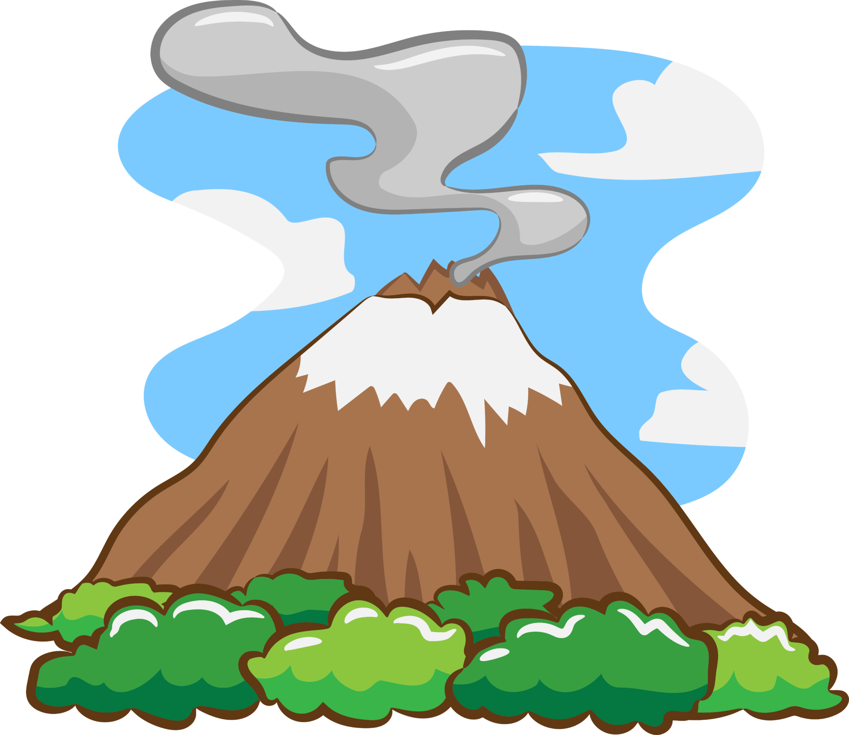
English
Throughout this term, children will be doing a combination of fiction and non-fiction writing. They will learn the features of non-chronological reports, recounts, explanations and narrative writing following the book ‘Pebble in my pocket’.
DT/Art
This term the children will look at the work of Nick Rowland to make their own volcano blow painting using straws. The children will also improve their sketching skills by drawing and shading different rocks through observation. For DT, they will create their own exploding volcano.
Science
This term the children will be rock explorers. Through practical experiments and research, the children will learn about different types of natural rock, how fossils and soil are formed.
Home Engagement
Family engagement
Please continue to read with your child as much as possible.
Homework, spellings and tables will continue to be sent out weekly. Please set aside time for your child to complete these to aid their learning.
Computing
We will be continuing our programming unit focusing on using commands on turtle logo before moving onto scratch.
Music
Spanish
Forest
This term, during PPA time, children will alternate between forest, music and Spanish. Children will be learning to play the recorder in music and learn days and months of the year in Spanish.
PE
Indoor: Dance/Gymnastics
Wednesday and Friday
Please make sure children wear a suitable PE Kit and footwear on these days so they are able to take part.

Geography
This term children will be studying volcanoes, earthquakes, tsunamis and tornados. Children will look at where and why these occur across the world. Children will learn all about the different layers of the Earth.
Year 3
Why are rocks important?
Term 2

