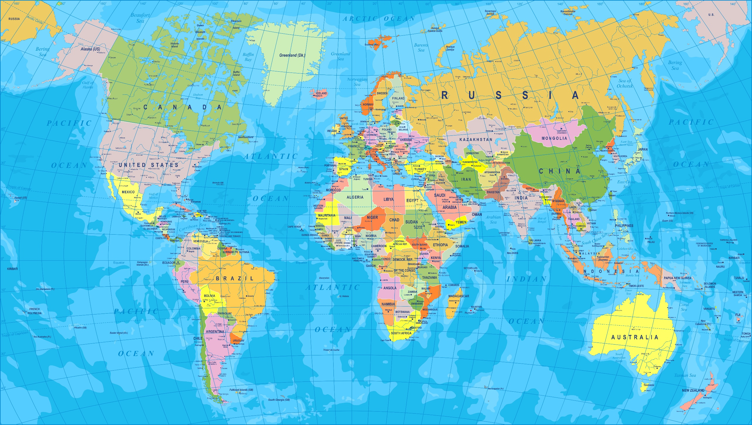
Computing
Programming – Making my program in scratch and using turtle logo.
Children will:
• Explore how to change sprites and backgrounds
• Explore Scratch and discover what they can make their sprite do – emphasis on discovering what individual blocks do
• Create a sequence to make a sprite move and turn
• Think through an algorithm and ‘RAG’ to self-assess
• Implement the algorithm as a dance program that includes sound.
Geography
In Geography, we are exploring the topic ‘Where in the World?’ This will be an investigative topic where the children will have the opportunity to explore different countries and cultures linked to some of the children’s own identities.
Forest
Children will be heading up to the forest every other Tuesday afternoon. Please ensure that children have waterproof coats and wellies, especially as the weather begins to change.
Art & DT
This term the children will be exploring Art from around the world.
English
This term we will be using the book ‘The day the crayons quit’ to revise some of our English skills and as a tool to develop and focus our writing around.
RE
This term the children will be looking at the story of the Creation.

PE
Cricket and Gymnastics
This term we are looking at cricket and gymnastics. Please ensure your child wears a full PE kit to school on these days. A white top (no football tops), black shorts or tracksuit bottoms and sensible trainers.
Science
This term the children will be studying light and covering the following objectives:
• recognise that they need light in order to see things and that dark is the absence of light
• notice that light is reflected from surfaces
• recognise that light from the sun can be dangerous and that there are ways to protect their eyes
• recognise that shadows are formed when the light from a light source is blocked by a solid object
• find patterns in the way that the size of shadows changes.
Maths
This term we will be looking at place value and numbers up to 1000. We will be revising and practising o9ur 2, 5 and 10 X tables. We will also develop formal written for addition and subtraction.
Where in the world?

