
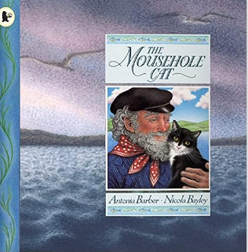
English
Purpose – narrative writing
Following our power of reading book, children we be writing setting descriptions using narrative techniques, as well as diary entries, brochures and newspaper reports related to our topic.

R.E

Learning about creation.

Computing
Write commands and program shapes using the turtle academy website:
- Use sequence, selection and repetition in programs
- Design, write and debug programs that accomplish specific goals
- Use logical reasoning to explain how some simple algorithms work

Art
- Blending colours with paint and pastels, as well as using different sketching skills to create landscapes

Music
This term children will follow the Bristol Beacon scheme of work where they will be learning about pulse and rhythm in singing and listening as well as the composition of music.

PSHE

Rights and responsibilities…
- What makes me unique?
- Learn how to make the right choices and recogonise that sometimes we make different choices than other people
- Understand where the body gets energy from and how to eat a balanced diet
- Learn the 7 Rs of recycling and how to care for the planet
- Define what the word community means and how a community can support one another
- Learn the basic concepts of first aid

Science
States of matter
How do we change a solid to a liquid?
How do we change a liquid into a solid?
How do we change liquid into a gas?
How do we classify items based on properties?
Geography
How does a river reach the sea?
What is the journey of a river?
What is flooding?
Can I map a river in Bristol?
What are waterfalls?
What is the river Thames and why is it important?

P.E
Cricket
- On Monday children learn how to work as a team developing their coordination, running, and passing skills taking on the different roles in each cricket game.

Gymnastics
- On Fridays children will be developing their coordination and core strength in putting together different gymnastics routines.

Maths
Place value –representing numbers up to 10,000 using various representations and number lines, as well as rounding to the nearest 10, 100 and 1000
Addition and Subtraction –
Adding and subtracting 4 digit numbers with and without exchanging
Term 1
What is the journey of a river?
Power of Reading:
The Mousehole Cat
Antonia Barber

