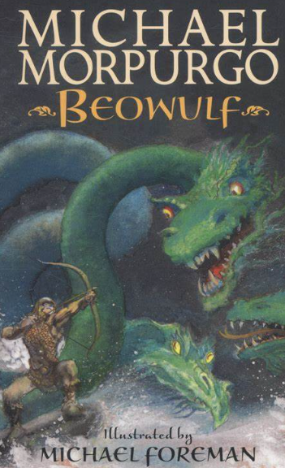
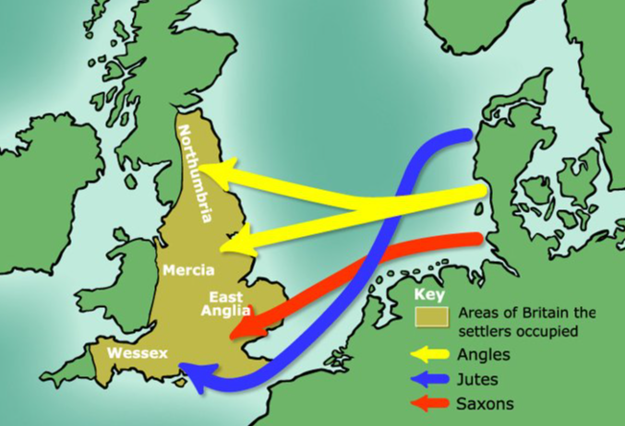
Science – Sound

- How is sound made?
- How do vibrations travel through our ear?
- What is volume and pitch?
- How does distance affect sound?

Art
- Design and create an Anglo-Saxons shield for a warrior.
- Create amulets and detail using salt dough.
- Loom-frame weaving
- Create a braid.
- Christmas cards.

Music
This term children will be learning how to play the recorder and practising for the Key Stage Two Christmas Concert!

R.E

Learning about saints, pilgrimages and Advent

Power of Reading:
Beowulf by Michael Morpurgo

Maths
- Estimating and checking answers
- Count squares and compare areas of shapes
- Multiplying and dividing by 10 and 100
- 3 x table (multiplication and division facts)
- 6 x table (multiplication and division facts)
- 7 times table (multiplication and division facts)
- 9 x table (multiplication and division facts)
- 11 x table (multiplication and division facts)
- 12 x table (multiplication and division facts)

PSHE

Me and my relationships:
- Describe good and not so good feelings.
- Postive and healthy relationships.
- When and how to say no.
- How to show good teamwork.
- Different feelings and how to manage them.
- When feelings change.

History
- Who were the Anglo-Saxons?
- What was Anglo-Saxon life like?
- Who was buried at Sutton Hoo and what does this tell us about the Anglo-Saxons?
- What did Anglo-Saxon settlements look like?
- How did Christianity evolve during Anglo-Saxon times?

English
Children we be writing a persuasive letter to Beowulf, a diary entry about a celebratory feast and newspapers reports to inform people about the events in Beowulf as well as the Anglo-Saxon invasion.

Computing
Continuing from last term using Turtle Academy:
- Use sequence, selection and repetition in programs
- Design, write and debug programs that accomplish specific goals
- Use logical reasoning to explain how some simple algorithms work

P.E
Handball
- On Thursday, children be building on their throwing, dribbling, jumping and catching skills in a series of handball sessions.
Dance
- On Fridays, children will be developing their coordination and core strength in putting together different dance routines, as well as performing and evaluating their sequences.

Term 2
Who were the Anglo-Saxons?

